**CUB SCOUT PACK**

**0000**

**CHARTERED ORGANIZATION NAME- CITY, OHIO**

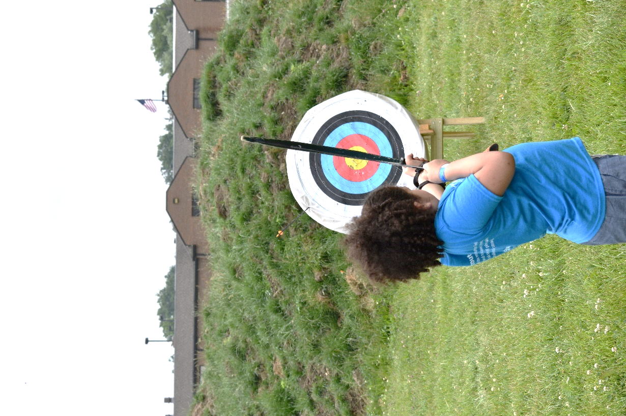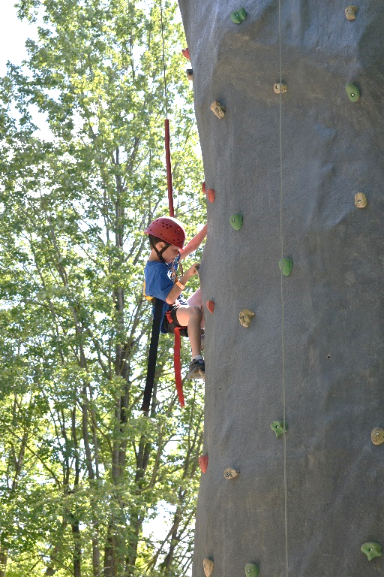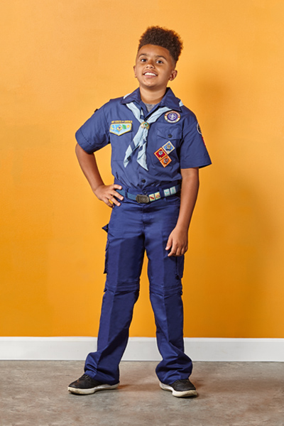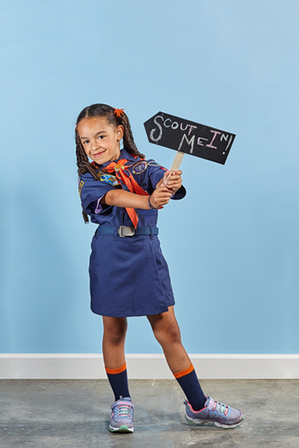

**Annual Membership Dues**

**$75**

What’s Included:

$34- BSA Membership Fee/Insurance

$17- Cub Scout Handbook

$10- Cub Scout Neckerchief

$9- Awards (Beltloops & Patches)

$5- Pinewood Derby Car

**One-Time Uniform Costs**

$25- Uniform Shirt

$25- Uniform Bottoms

$12- Uniform Patches

$10- Uniform Belt

$15- Uniform Hat