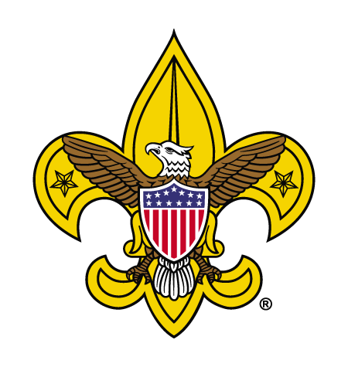
SCOUTS BSA TROOP
0000
CHARTERED ORGANIZATION NAME- CITY, OHIO

Troop Adult Leader Contact Sheet
Name | Leadership Position | Phone # | E-mail
 | Scoutmaster
 | Assistant Scoutmaster
 | Assistant Scoutmaster
 | Assistant Scoutmaster
 | Assistant Scoutmaster
 | Assistant Scoutmaster
 | Assistant Scoutmaster
 | Assistant Scoutmaster
 | Committee Chairperson
Committee Member
Secretary
Committee Member
Treasurer
Committee Member
Fundraising Chair
Committee Member
New Member Coordinator
Committee Member
Camping/Outings Chair
Committee Member
Troop Trainer
Committee Member
Advancement Chair
 | Chartered Organization Rep.
Troop Meetings are held [every] [Day] from [time to time] at [location & address]

Scouts BSA Troop Organizational Overview
Patrol
A Scout patrol is a small team of normally six to eight members where Scouts learn skills together, share responsibilities and take on leadership roles.
Troop
The troop is a youth-run organization made up of several patrols. The size of the troop varies based on local interest and resources. Each troop is identified by a number.
Scoutmaster
The Scoutmaster is the adult responsible for working directly with the Scouts providing direction, coaching, and support.
Assistant Scoutmasters
An assistant Scoutmaster is an adult leader over the age of 18 who helps the Scoutmaster deliver the promise of Scouting. Each assistant Scoutmaster is assigned specific program duties.
Troop Committee
The troop committee is a cross between a board of directors and a parent support group. It sets troop policies and handles administrative functions, allowing the Scoutmaster and assistant Scoutmasters to focus on working directly with the Scouts.
Troop Committee Chair
The troop committee chairman is appointed by the chartered organization to see that all committee functions are carried out. The troop committee chairman appoints and supervises the unit committee and unit leaders and organizes the committee to see that all committee responsibilities are delegated, coordinated and completed.
Chartered Organization
This is the organization that partners with the Boy Scouts of America to deliver a Scouting program. They adopt Scouting to serve the youth in the community.
Chartered Organization Representative
This person appoints the Troop Committee Chair and approves all adult leaders. They provide resources from the chartered organization.
Lake Erie Council, Boy Scouts of America
The Boy Scouts of America provides a charter to a community board of volunteers to be responsible for providing the Scouting program to a defined geographical area called a council. Councils have a volunteer board which employs a Scout Executive to serve as the CEO and give leadership to the day to day operation. The Scout Executive hires staff to provide direct and indirect support to local Scouting programs. In each council there are many more volunteers than staff as the organization is volunteer lead and professionally guided.
Unit Serving Executive
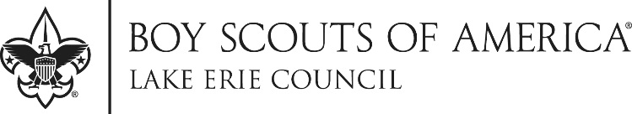
A full-time employee of the Lake Erie Council who provides support to the volunteers who run the day-to-day operation of the pack.

