CUB SCOUT PACK

0000
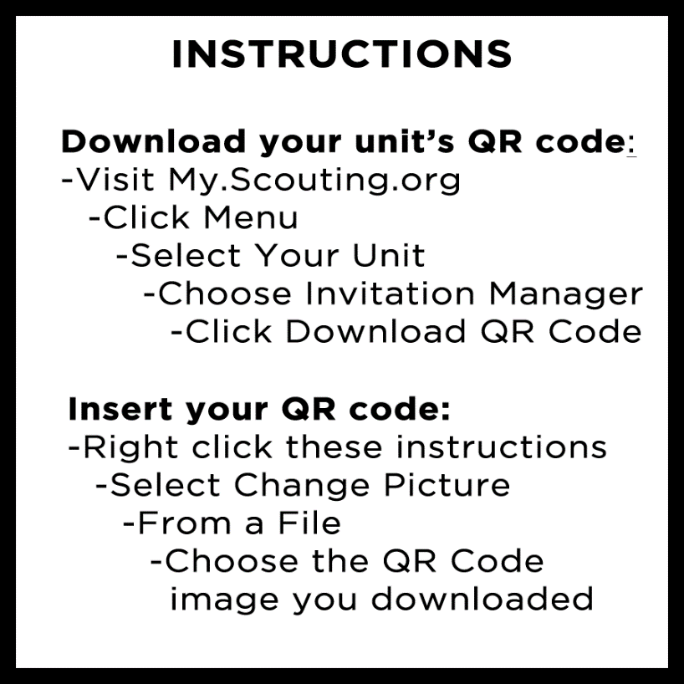

Join Online!

→ Scan the QR Code
→ Create an account
→ Complete the digital form

CUB SCOUT PACK
0000

Sign up Online!

→ Scan the QR Code
→ Create an account
→ Complete the digital form

